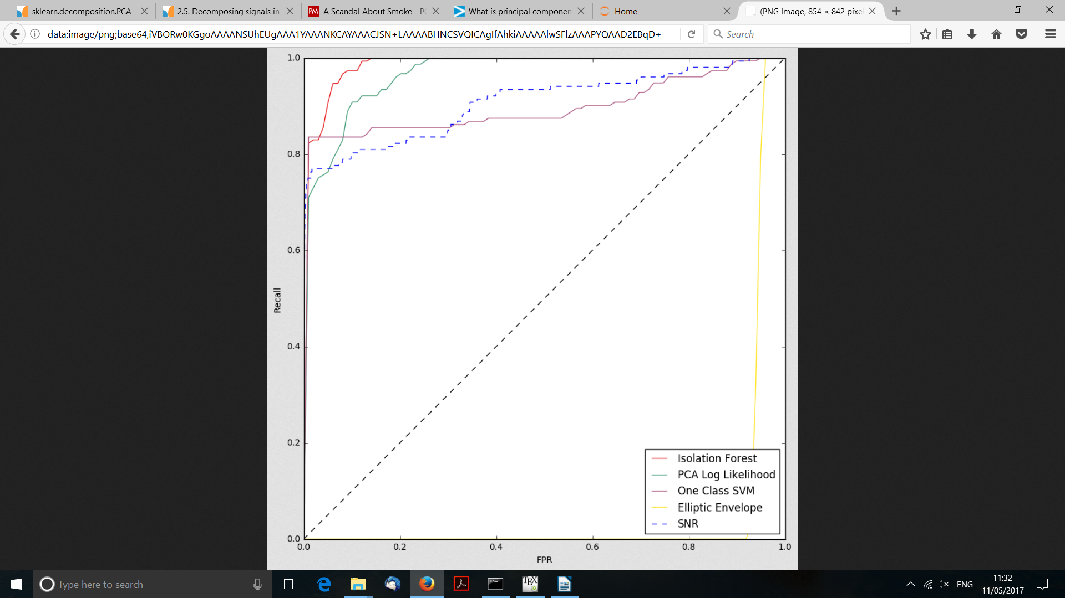
frbs
Isolation Forest ROC Score: 0.988494976079 +/- 0.00786679987341
PCA Log Likelihood ROC Score: 0.969371295073 +/- 0.0183290717173
One Class SVM ROC Score: 0.898826296741 +/- 0.0750450274029
Elliptic Envelope ROC Score: 0.0566201335536 +/- 0.00225349107719
htru2
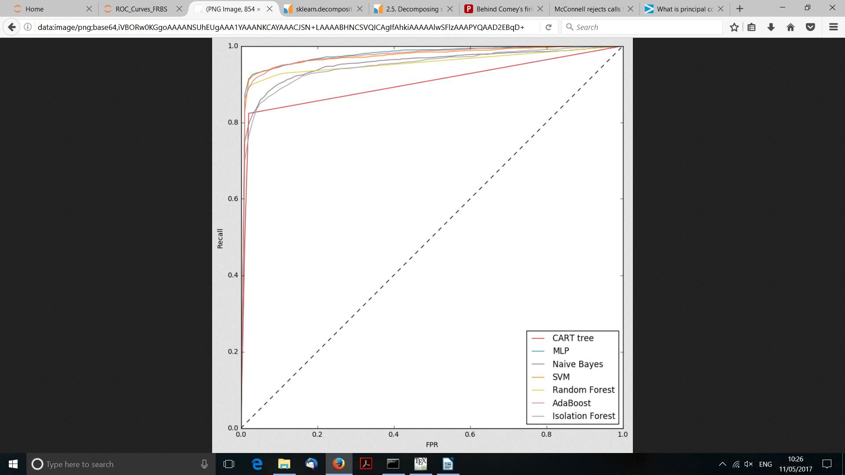
CART tree ROC Score: 0.903043660411 +/- 0.0129214120827
MLP ROC Score: 0.979928721228 +/- 0.00569764429079
Naive Bayes ROC Score: 0.95509594487 +/- 0.0112160386144
SVM ROC Score: 0.973228863559 +/- 0.0101299542551
Random Forest ROC Score: 0.956782543843 +/- 0.0108052893216
AdaBoost ROC Score: 0.977220462048 +/- 0.00459880118686
Isolation Forest ROC Score: 0.950022202541 +/- 0.00587489301355

